29/09/2022

MAPD713_Enterpise Techs Mobile Platforms

Assignment 1

# Working demo will be there in the video, this word document shows the screenshots of the HTTP Server JSON code, GitHub linked and a link to view the files. Also the sequence diagram which will be present in the zip file and a screenshot of the POSTMAN application with the solution implemented and working.

# Git control

# 

# 

# GitHub link: <https://github.com/Titanhood/MAPD713_Assignment1/tree/master>

# COMMIT HISTORY

# 

# HTTP server js file

# 

# Post

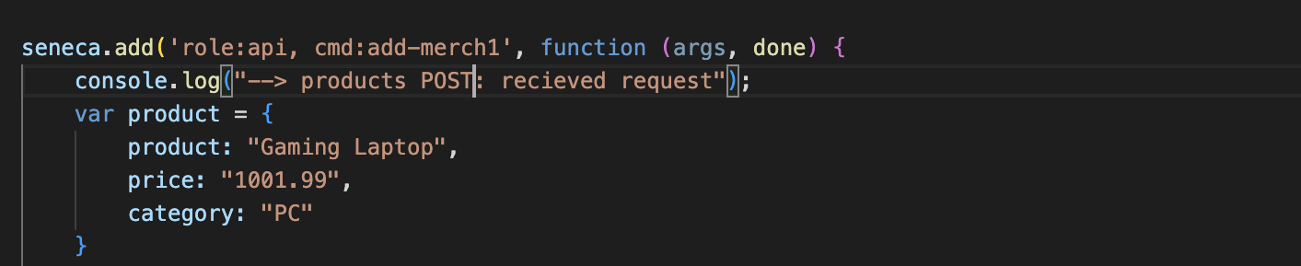

Request Counter and URL

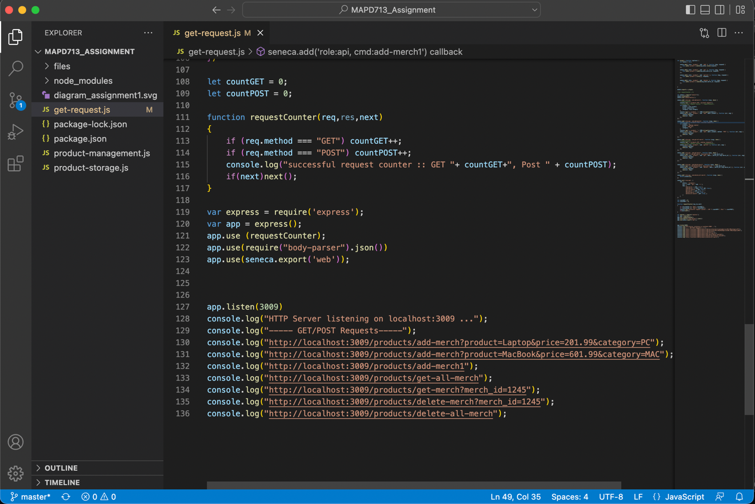

Running the HTTP Server

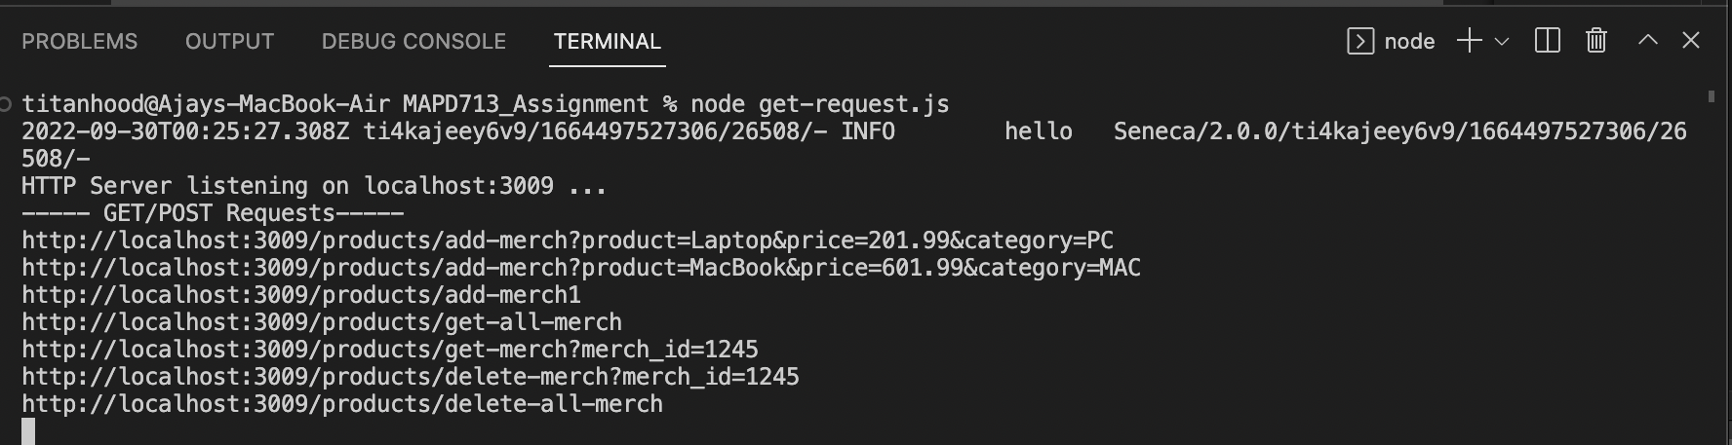

GET request

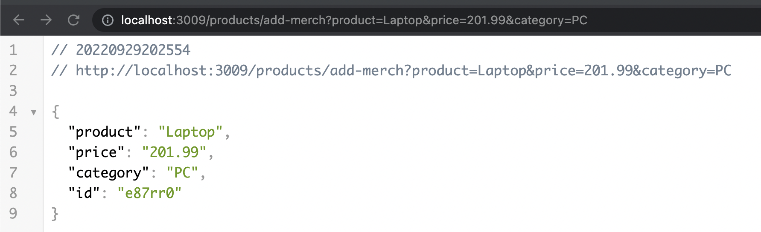

POST Request

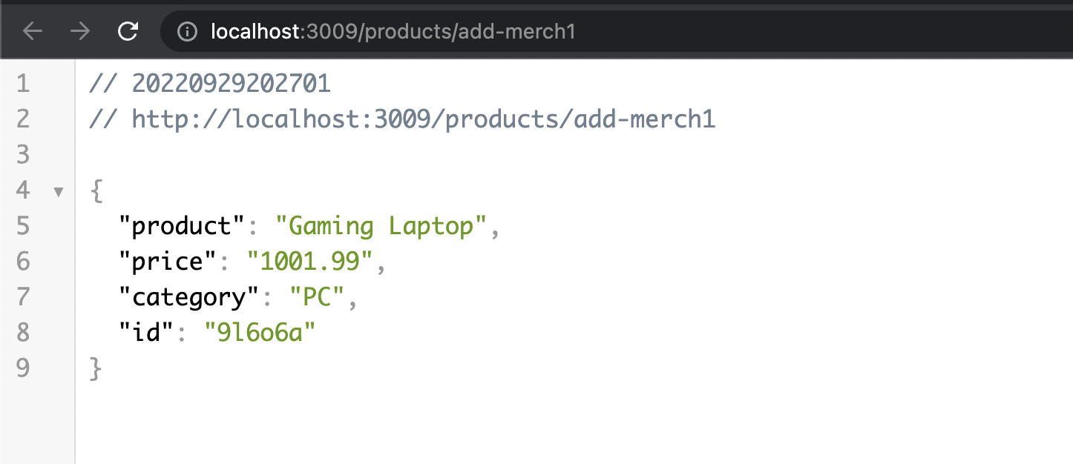

GET all products

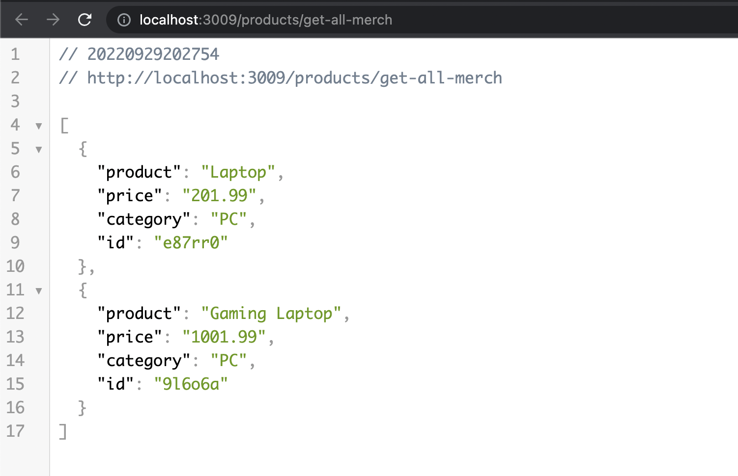

Request Counter in action:

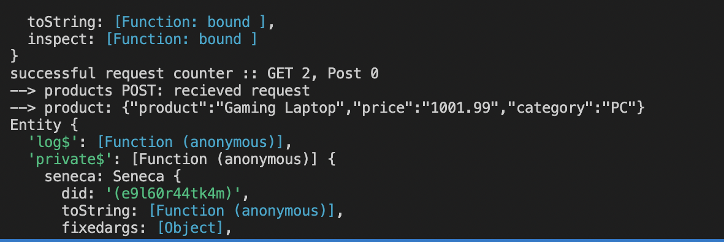

Sequence Diagram:

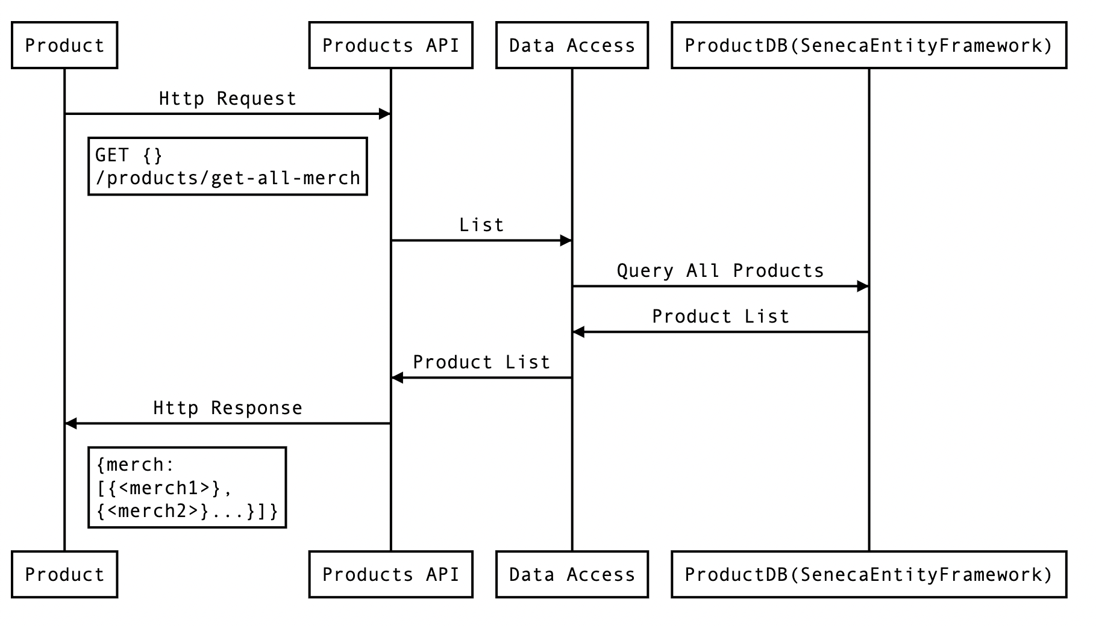

POSTMAN application, solution working and in action in postman.

